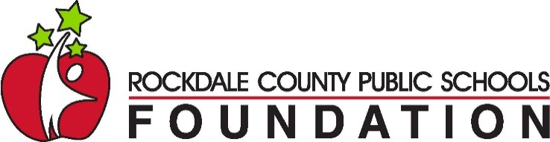

The Collins Family
Aspiraciones Más Grandes

Scholarship 2024
The Collins Family Scholarship will award a total of three, $3,000 scholarships to qualifying RCPS seniors who are of Hispanic/Latino descent, regardless of citizenship status. First preference will be given to first generation college students*.

To apply, a student must:

- be of Hispanic/Latino ethnicity,
- be a 2024 graduate in a Rockdale County public school,
- be accepted to a college or technical school for the 2024-25 school year, and
- complete an application and 500-word essay.

*First generation college student is defined as neither parent having attended a college or technical school program.

APPLICATION and ESSAY:
Essay: (500 words max.) Explain the importance of going to college or technical school for you personally and the impact you feel it will have on future generations in your family.

Please fill out the information below and attach your essay to this form and return to cball@rockdale.k12.ga.us no later than Friday, April 22, 2024, to be considered for this scholarship. The scholarship will be awarded after May 13, 2024.

Last Name First Name MI

Address_______________________________________________________________________

City State Zip

Home Phone: Cell Phone:

Email: _________________________________________________________________

High School:
I have been accepted to and will be attending:

(name of college or technical school for the 2024-25 school year)

